Hostel Room Allocation System

DBMS Project

Ashutosh Rai 205119021

## 1/29

* Hostel Room allocation system is a web application which aims at computerization of current procedure of allocating hostel rooms.
* Currently the process involves students filling up the forms and submitting them in respective hostel offices which involves a lot of paperwork, hence less efficient !

## 2/29



3/29

1. Student
2. Hostel Manager
3. Admin

# Student

## 4/29

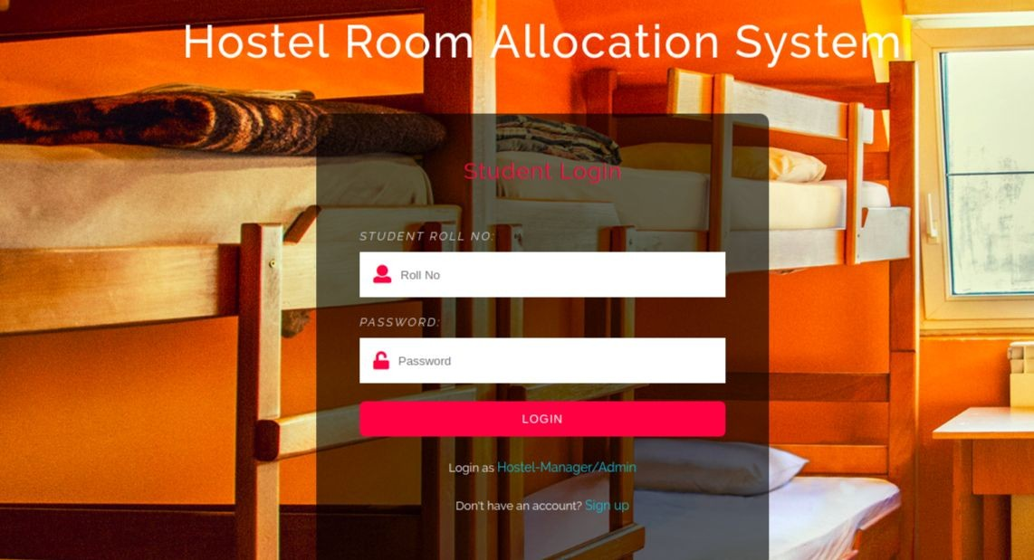**Login Page**

* + If and only if the user exists in DB and password entered is correct, he/she will be able to login, otherwise appropriate error message is displayed.

## 5/29

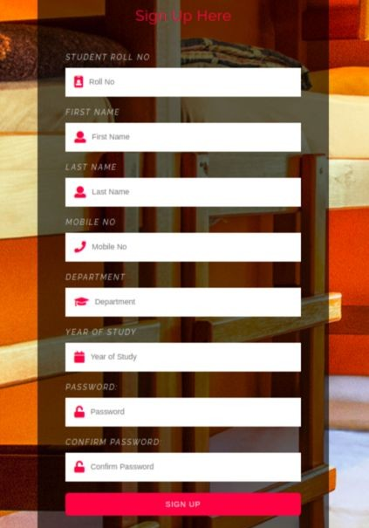

**Sign Up Page**

* + - Students who are not a part of the portal can register themselves here.
    - **Hostel Manager cannot sign up, he/she can only login. Hostel manager can only be created by Admin!**
    - All the necessary error conditions are checked.(like if a user with the entered roll number already exists).

## 6/29

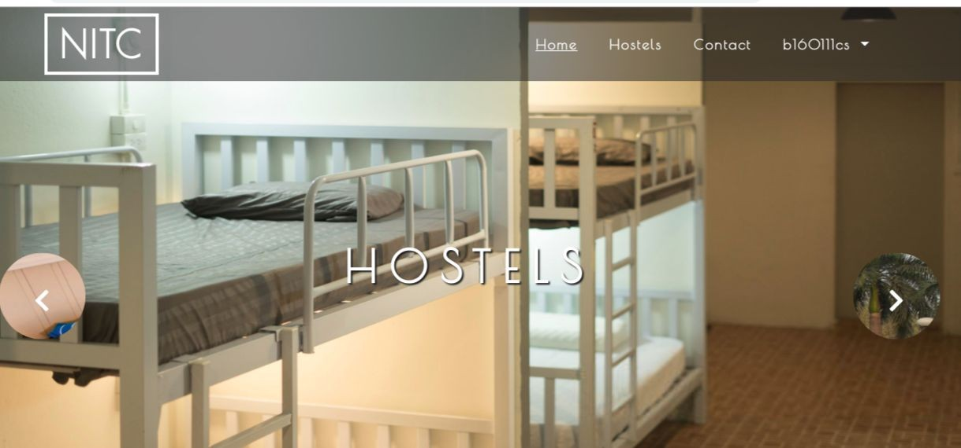

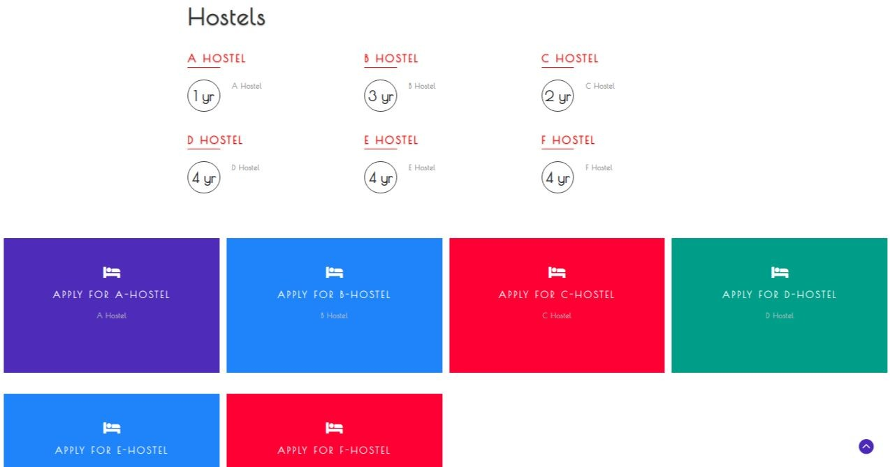

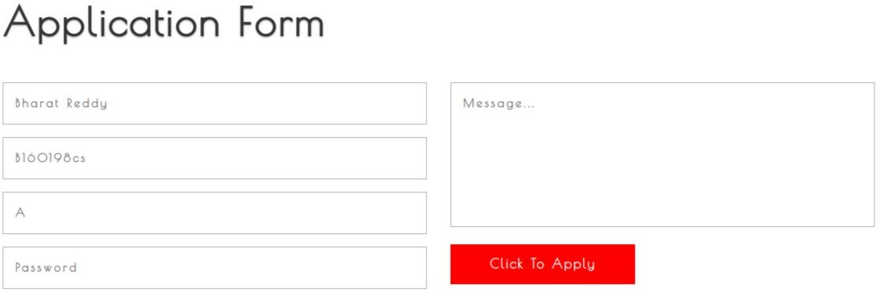

* + Student Should enter password to confirm
  + If the student is already allocated room, he won’t be allowed to submit any application forms.

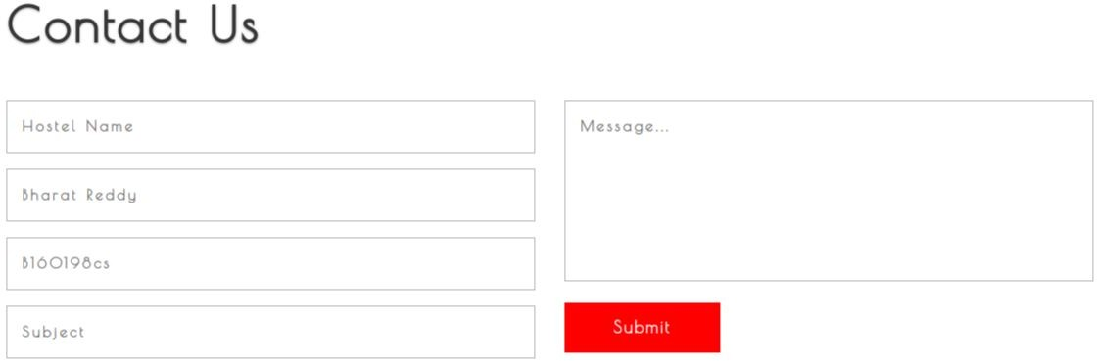

* + Student can send messages to hostel manager by filling up this form and clicking on the submit button.

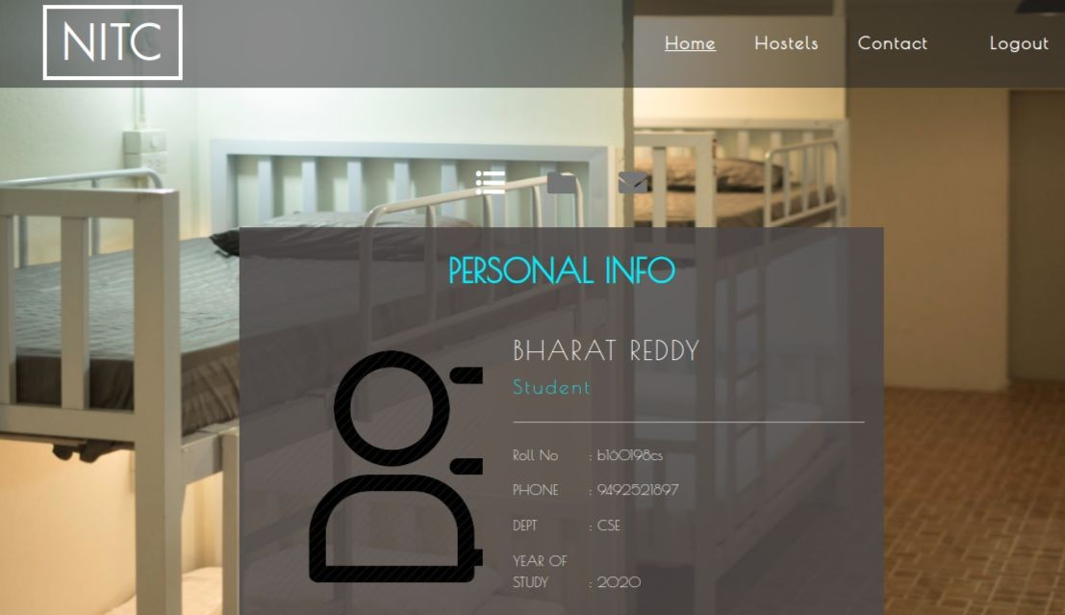

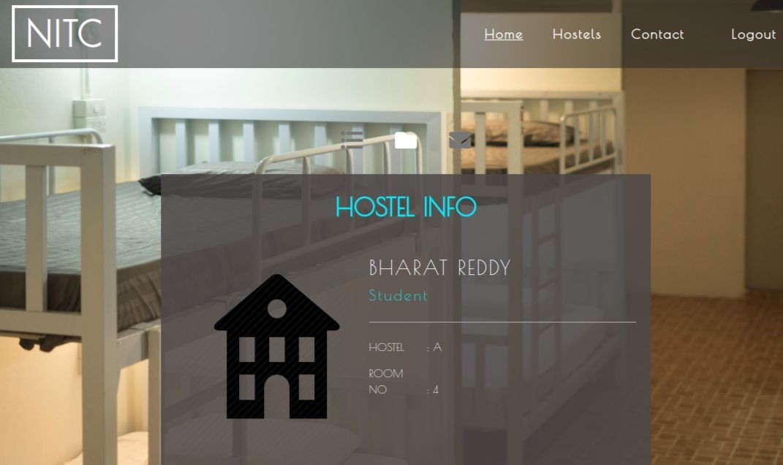

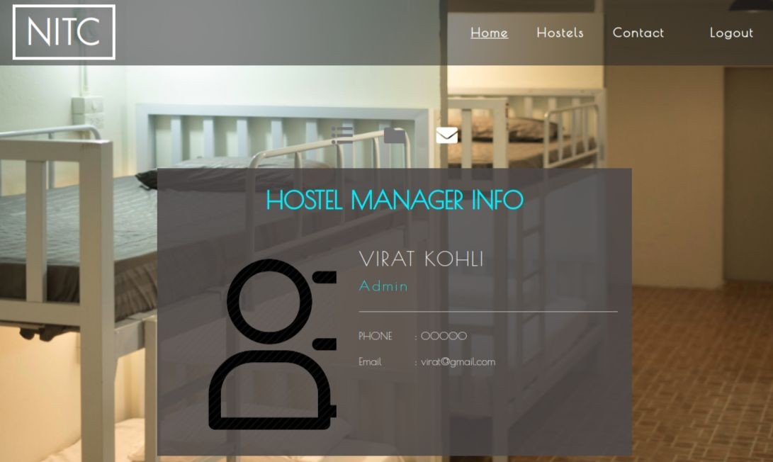

# Hostel Manager

## 14/29

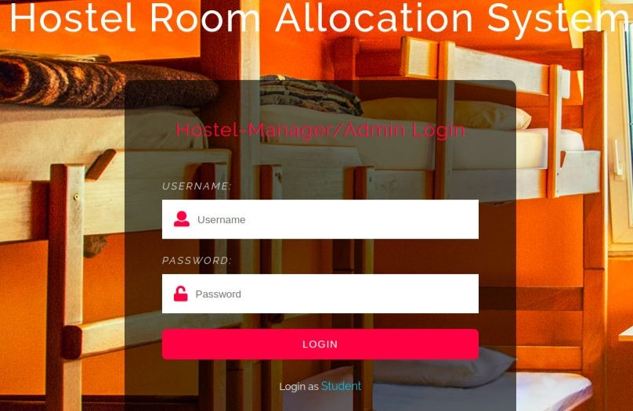

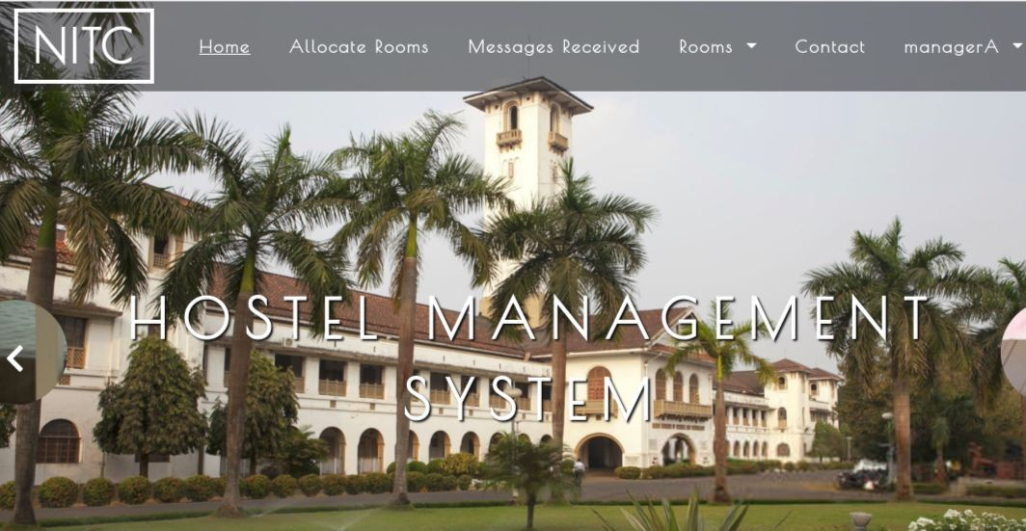

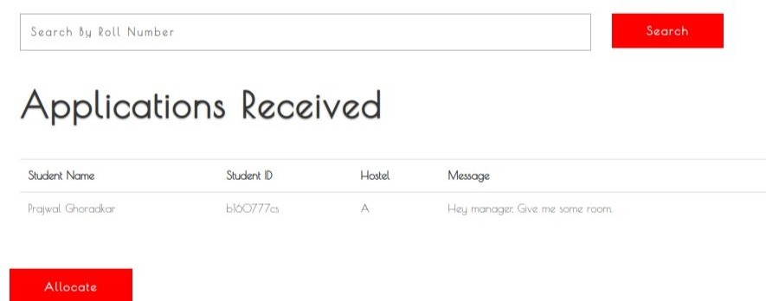

Possible Error Checks

* + - Once a hostel becomes full the manager won’t be able to allocate a room for student. So he/she will send a message to student saying that the rooms are full.
    - If a student is already allocated a room, he can’t apply to any other hostel.

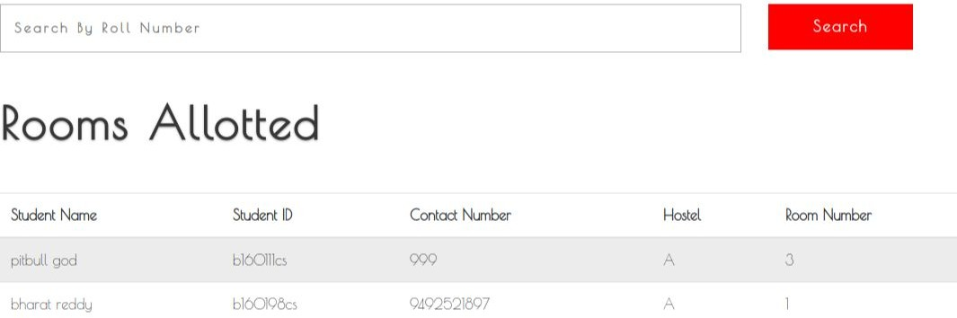

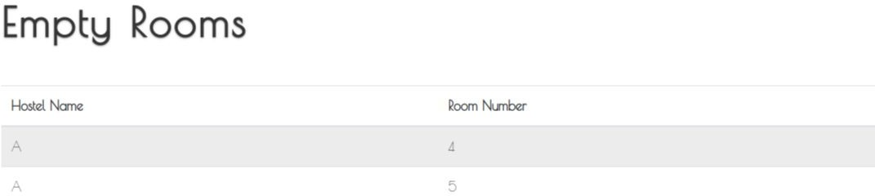

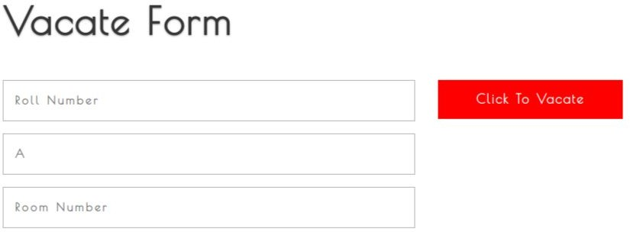

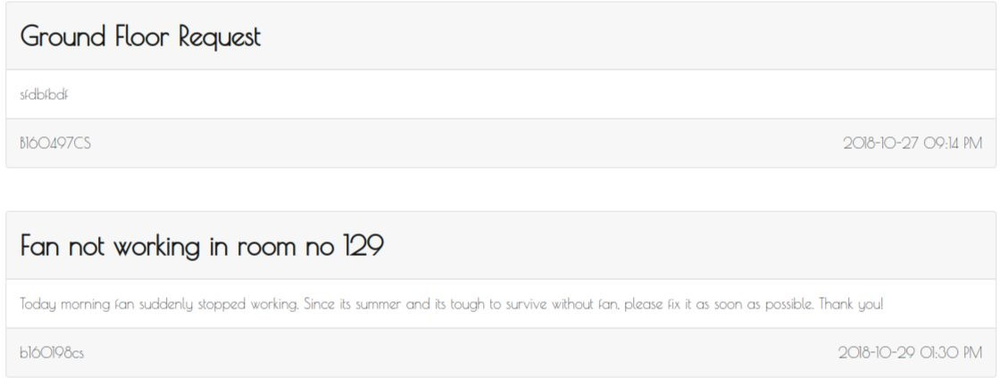

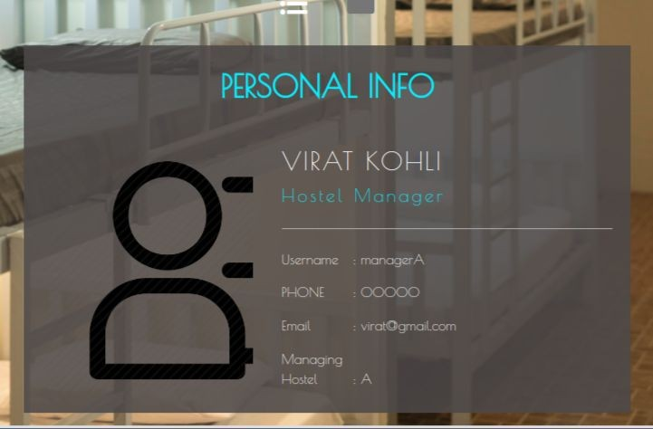

Admin

24/29

**Admin Home Page**

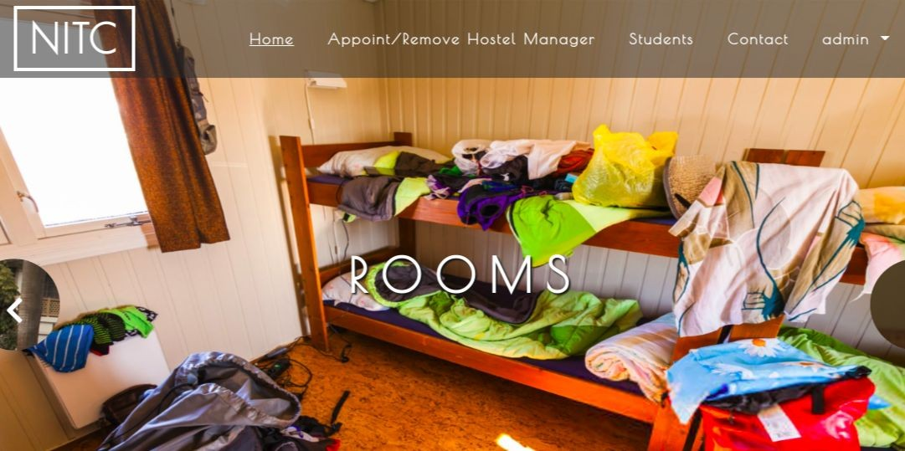25/29

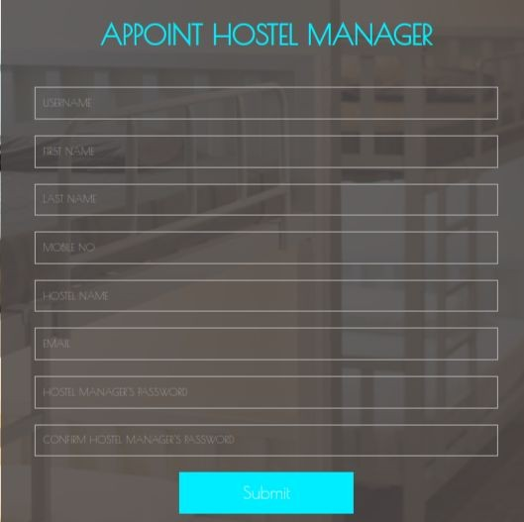

**Appoint Hostel Manager**

**Remove Hostel Manager**

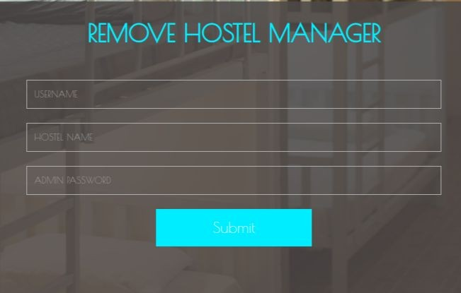

**Students Page**

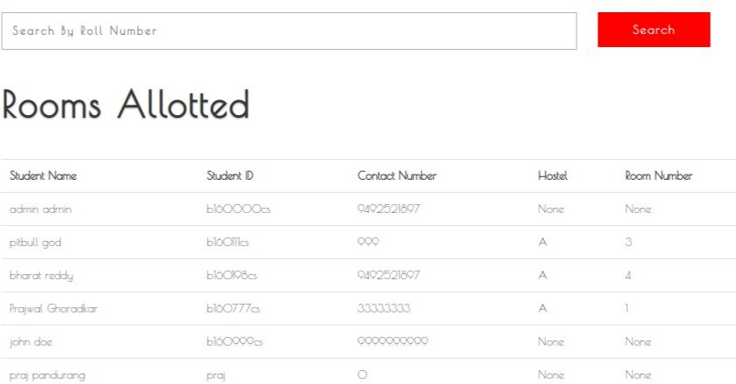

**Admin Profile Page**

